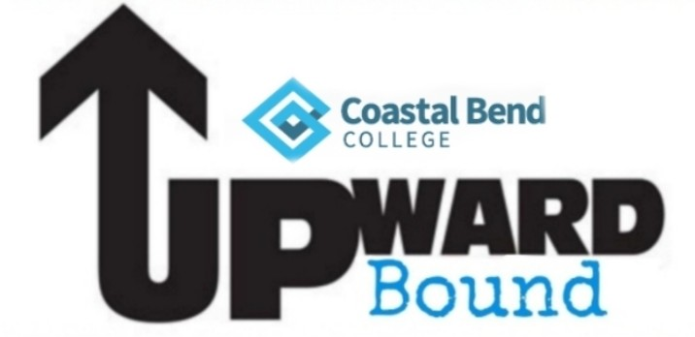

Please fill out the following information and email back to your advisor:
Amanda Ramirez (Upward Bound: AC Jones, Mathis, Pettus) alramirez1@coastalbend.edu.
Stephanie Hollis (Upward Bound Rural: George West, Sinton, Odem) shollis@coastalbend.edu
Name: | Grade & School:
Cell Phone: | Email:
Parent Name: | Parent Phone number:
Parent Email:

Are you interested in participating in any of the following clubs?

- STEM Club _______
- Media Club ______
- Art Club _________
- Book Club________

If you have trouble sending this back as an attachment, feel free to just email the answers back.

